Hazelnut and chocolate muffins
 | Ingredients
 | brown sugar  (125 g) | 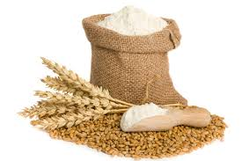 | flour  (70 g)
 | butter  (125 g) | 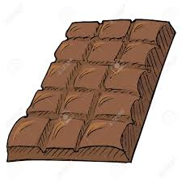 | chocolate  (60 g)
   | 2 eggs  Icing  cream  (125 g) | 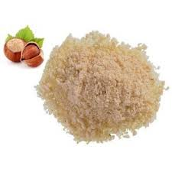 | hazelnut powder  (40 g)  chocolate  (120g)
 | Instructions : muffins
Preheat oven to 180°.
Beat sugar and melted butter until well blended. Add eggs and mix well.
Add flour and hazelnut powder. Mix well.
Add melted chocolate. Mix well
Pour dough into the cake mold.
Bake 10-12 minutes

Instructions :icing
Mix melted chocolate and cream. When it thickens, spread on the muffins.

